How to Send Email notification in HCI
Step 1: Configure Sender (SOAP) / Sample Interface
Step 2: Configure Receiver (Mail)

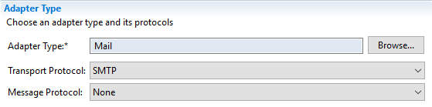

Remember the Credential Name, you will use it during Artifact Deployment in HCI.
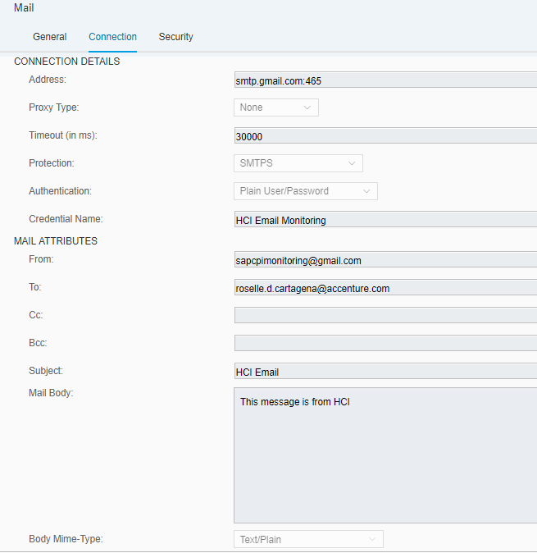

Step 3: Configure Gmail Account.
- Go to MyAccount-> Sign-in & Security
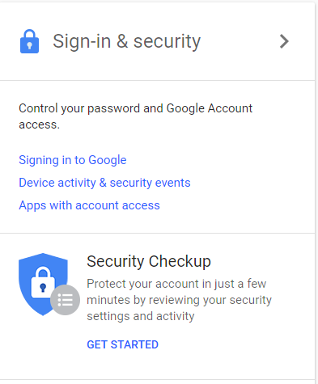

- Enable 2 Step Verification, by default this is disabled
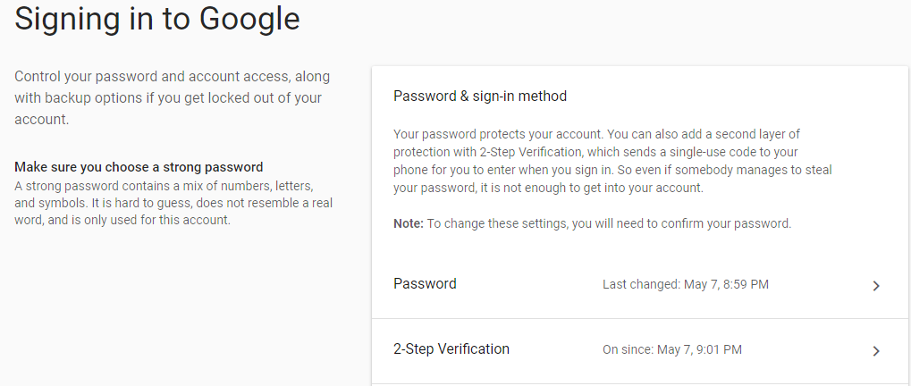

- Once enabled, you will see App Password. Configure App Password for HCI.
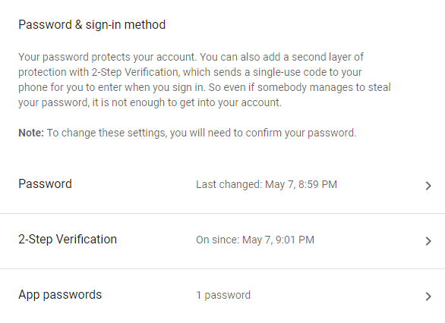

- In Select App choose Other (Custom Name)
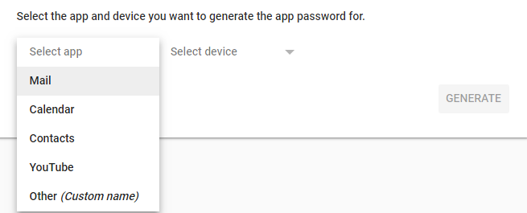

- Enter the Name you entered in Credential Name in Step 2. Click generate for the Password.
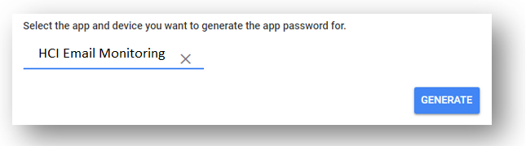
- Save the password.
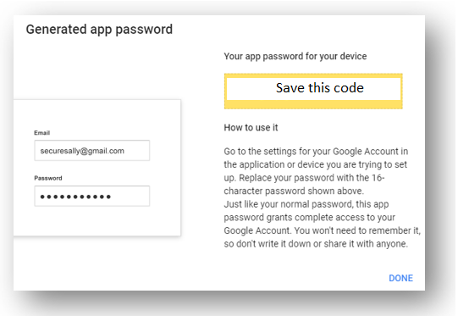

Step 4: Deploy the credential using the password in step 3
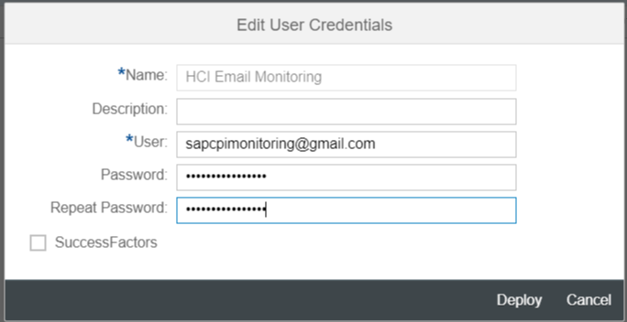

- Finally, you can now run the Webservice/Interface to send email.
Output

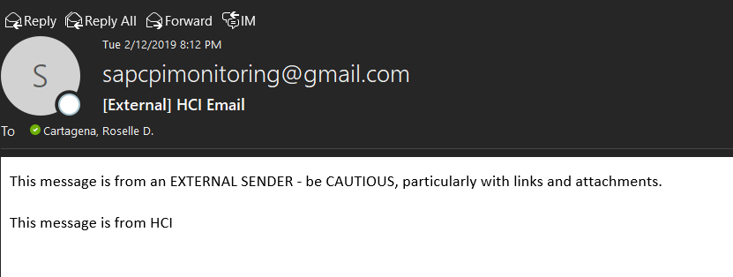

Testing the Connectivity
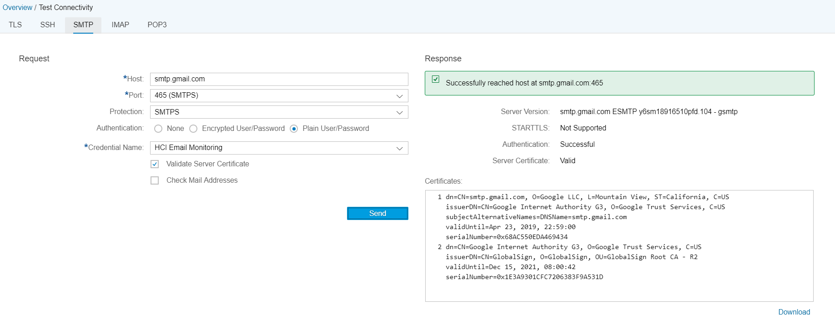
Install google certificate and gmail certificate
